1.Our method, called Mask R-CNN, extends Faster R-CNN [29] by adding a branch for predicting segmentation masks on each Region of Interest (RoI), in parallel with the existing branch for classiﬁcation and bounding box regression (Figure 1)

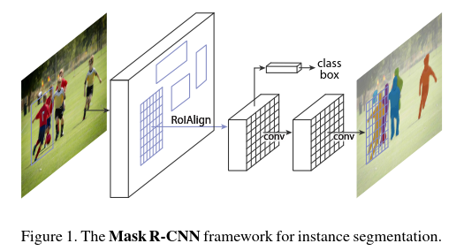

In principle Mask R-CNN is an intuitive extension of Faster R-CNN, yet constructing the mask branch properly is critical for good results.增加了mask分支之后，检测结果得到了显著提升。

2.RoIPool [14, 9], the de facto core operation for attending to instances, performs coarse spatial quantization for feature extraction. To ﬁx the misalignment, we propose a simple, quantization-free layer, called **RoIAlign**, that faithfully preserves exact spatial locations. **including pixel-to-pixel alignment**

作者嫌弃RoIPool不够精确，空间信息不完全。提出了一种叫RoIAlign的结构。

3. We use bilinear interpolation [18] to compute the exact values of the input features at four regularly sampled locations in each RoI bin, and aggregate the result (using max or average)

采用双线性插值的方法，来增大特征图到指定的尺寸。

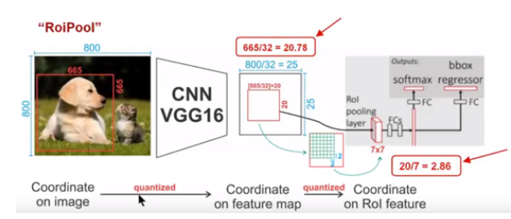

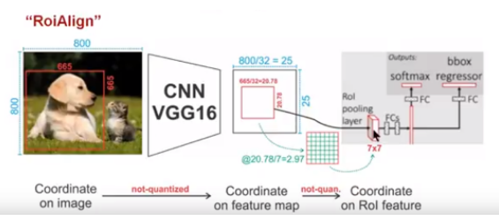

线性插值，和非线性插值。

https://blog.csdn.net/kk123k/article/details/86563425